1. package day8.selenium;

import org.testng.annotations.Test;

import org.testng.annotations.BeforeTest;

import org.openqa.selenium.By;

import org.openqa.selenium.Keys;

import org.openqa.selenium.WebDriver;

import org.openqa.selenium.WebElement;

import org.openqa.selenium.firefox.FirefoxDriver;

import org.testng.annotations.AfterTest;

public class Ca1Test {

WebDriver driver;

@BeforeTest

public void beforeTest() {

driver=new FirefoxDriver();

}

@Test

public void Test() throws InterruptedException {

String url="https://www.amazon.in/";

driver.get(url);

driver.manage().window().maximize();

Thread.sleep(5000);

System.out.println("opened");

// System.out.println("opened");

driver.findElement(By.xpath("//*[@id=\"twotabsearchtextbox\"]")).sendKeys("Rings",Keys.ENTER);

Thread.sleep(10000);

driver.findElement(By.xpath("/html/body/div[1]/div[2]/div[1]/div[1]/div/span[1]/div[1]/div[1]/div/div/div[1]/div[2]/div[2]/div[1]/div/a[2]/div/div[1]/img")).click();

Thread.sleep(7000);

driver.findElement(By.xpath("//*[@id=\"add-to-cart-button\"]")).click();

Thread.sleep(2000);

driver.findElement(By.xpath("/html/body/div[1]/div[2]/div/div[1]/div[2]/div/div[3]/div/div[1]/span/span/a")).click();

Thread.sleep(2000);

driver.findElement(By.xpath("//*[@id=\"a-autoid-0-announce\"]")).click();

Thread.sleep(1000);

driver.findElement(By.xpath("//*[@id=\"quantity_4\"]")).click();

Thread.sleep(2000);

driver.findElement(By.xpath("/html/body/div[1]/div[2]/div[3]/div[5]/div/div[2]/div[1]/div/form/div[2]/div[3]/div[4]/div/div[2]/div[1]/span[2]/span/input")).click();

Thread.sleep(5000);

driver.navigate().to("https://www.amazon.in/dp/B09LM98LRT/ref=redir_mobile_desktop?_encoding=UTF8&aaxitk=b64f891a4fd6ae0703bbcb946aabe933&content-id=amzn1.sym.df4bf09f-d6a1-4ca3-98bc-ee2a82b34bf9%3Aamzn1.sym.df4bf09f-d6a1-4ca3-98bc-ee2a82b34bf9&hsa_cr_id=5574300390202&pd_rd_plhdr=t&pd_rd_r=5bafbc7a-2309-413e-b634-b7425bde9fa0&pd_rd_w=j7zzL&pd_rd_wg=KH7Ag&qid=1683189619&ref_=sbx_be_s_sparkle_lsi4d_asin_0_img&sr=1-1-e0fa1fdd-d857-4087-adda-5bd576b25987");

Thread.sleep(5000);

driver.findElement(By.xpath("//*[@id=\"add-to-cart-button\"]")).click();

Thread.sleep(4000);

driver.findElement(By.xpath("/html/body/div[1]/div[2]/div/div[1]/div[2]/div/div[3]/div/div[1]/form/span/span/span/input")).click();

Thread.sleep(4000);

driver.findElement(By.xpath("//*[@id=\"ap_email\"]")).sendKeys("7418736104",Keys.ENTER);

Thread.sleep(2000);

driver.findElement(By.xpath("//*[@id=\"ap_password\"]")).sendKeys("Charishmatic04",Keys.ENTER);

Thread.sleep(4000);

WebElement total=driver.findElement(By.xpath("/html/body/div[5]/div[1]/div/div[2]/div/div/div[2]/div/div[1]/div/div[2]/div/div[1]/div/table/tbody/tr[4]/td[2]"));

String ttotal=total.getText();

System.out.println("Order Total: "+ttotal);

Thread.sleep(4000);

// driver.findElement(By.xpath("/html/body/div[5]/div[1]/div/div[1]/div/div[1]/div/div[2]/span/span/div/i[1]")).click();

}

@AfterTest

public void afterTest() {

driver.quit();

}

}

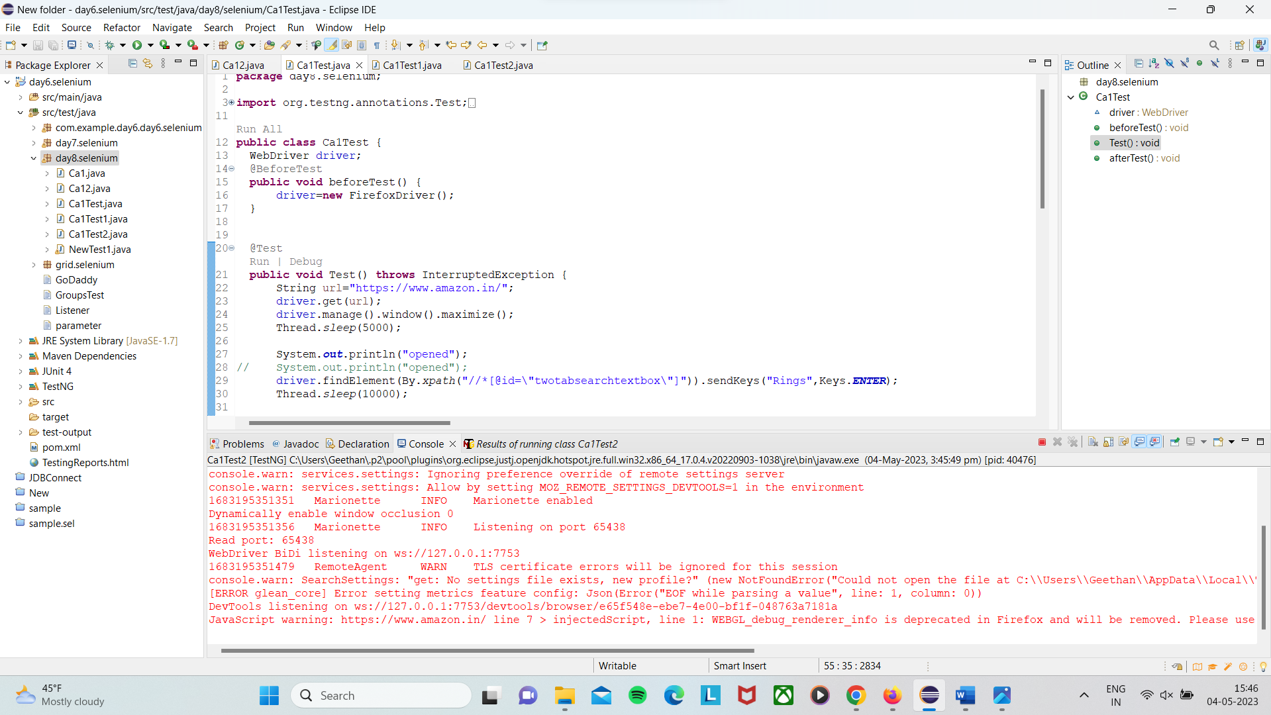

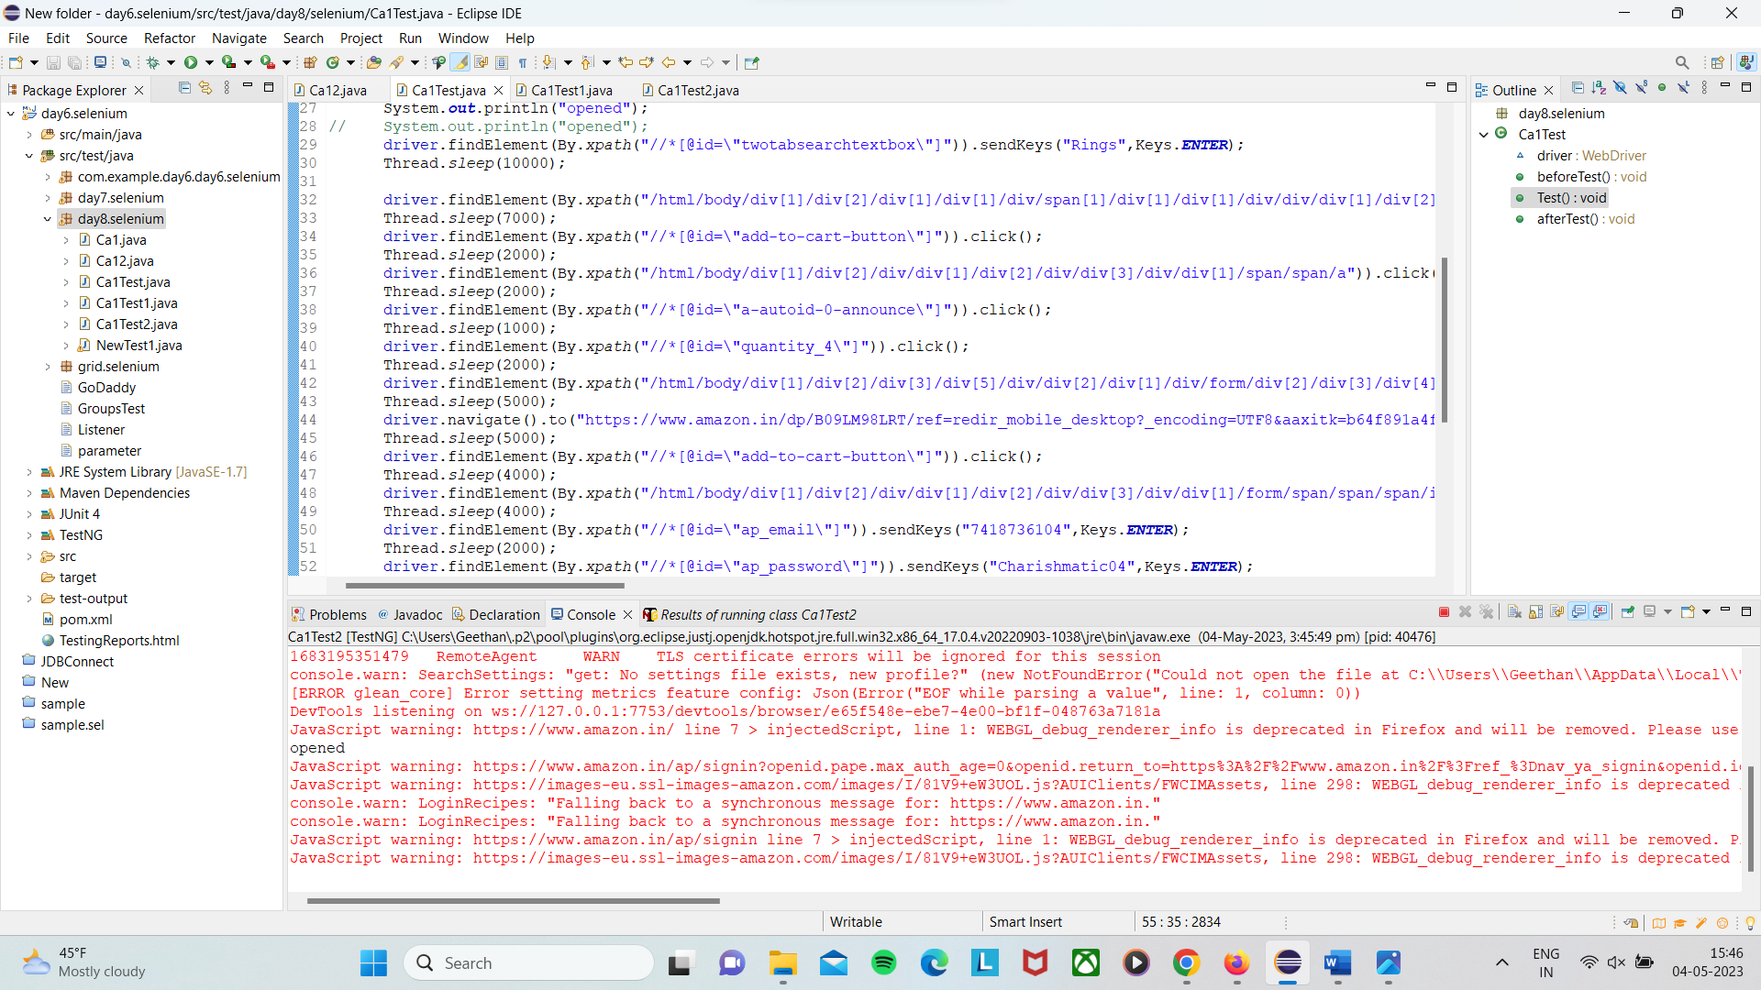

2. package day8.selenium;

import org.testng.annotations.Test;

import org.testng.annotations.BeforeTest;

import org.openqa.selenium.By;

import org.openqa.selenium.Keys;

import org.openqa.selenium.WebDriver;

import org.openqa.selenium.WebElement;

import org.openqa.selenium.firefox.FirefoxDriver;

import org.testng.annotations.AfterTest;

public class Ca1Test1 {

WebDriver driver;

@BeforeTest

public void beforeTest() {

driver=new FirefoxDriver();

}

@Test

public void Test() throws InterruptedException {

String url="https://www.amazon.in/";

driver.get(url);

driver.manage().window().maximize();

Thread.sleep(5000);

System.out.println("opened");

// System.out.println("opened");

driver.findElement(By.xpath("//*[@id=\"twotabsearchtextbox\"]")).sendKeys("Rings",Keys.ENTER);

Thread.sleep(10000);

WebElement name=driver.findElement(By.xpath("/html/body/div[1]/div[2]/div[1]/div[1]/div/span[1]/div[1]/div[1]/div/div/div[1]/div[1]/div/div[2]/div/a/span/span[2]"));

String tname=name.getText();

System.out.println("First product "+tname);

WebElement name2=driver.findElement(By.xpath("/html/body/div[1]/div[2]/div[1]/div[1]/div/span[1]/div[1]/div[3]/div/div/div/div/div/div/div[2]/div[1]/h2"));

WebElement name3=driver.findElement(By.xpath("/html/body/div[1]/div[2]/div[1]/div[1]/div/span[1]/div[1]/div[4]/div/div/div/div/div/div/div[2]/div[1]/h2"));

WebElement name4=driver.findElement(By.xpath("/html/body/div[1]/div[2]/div[1]/div[1]/div/span[1]/div[1]/div[5]/div/div/div/div/div/div/div[2]/div[1]/h2"));

WebElement name5=driver.findElement(By.xpath("/html/body/div[1]/div[2]/div[1]/div[1]/div/span[1]/div[1]/div[6]/div/div/div/div/div/div/div[2]/div[1]/h2"));

String tname2=name2.getText();

String tname3=name3.getText();

String tname4=name4.getText();

String tname5=name5.getText();

System.out.println("2nd Product "+tname2);

System.out.println("3rd Product "+tname3);

System.out.println("4th Product "+tname4);

System.out.println("5th Product "+tname5);

driver.findElement(By.xpath("/html/body/div[1]/div[2]/span/div/h1/div/div[2]/div/div/form/span/span/span/span/span[2]")).click();

Thread.sleep(1000);

driver.findElement(By.xpath("//*[@id=\"s-result-sort-select_1\"]")).click();

Thread.sleep(5000);

WebElement lp=driver.findElement(By.xpath("/html/body/div[1]/div[2]/div[1]/div[1]/div/span[1]/div[1]/div[3]/div/div/div/div/div[2]/div[2]/div[1]/a/span/span[2]/span[2]"));

String tlp=lp.getText();

System.out.println("Low to high -> first product price"+tlp);

// driver.findElement(By.xpath("/html/body/div[1]/div[2]/span/div/h1/div/div[2]/div/div/form/span/span/span/span/span[2]")).click();

// Thread.sleep(2000);

// driver.findElement(By.xpath("//*[@id=\"s-result-sort-select_2\"]")).click();

// Thread.sleep(4000);

// WebElement hp=driver.findElement(By.xpath("/html/body/div[1]/div[2]/div[1]/div[1]/div/span[1]/div[1]/div[11]/div/div/div/div/div[2]/div[2]/div/a/span[1]/span[2]/span[2]"));

// String thp=hp.getText();

// System.out.println("High to low -> first product price"+thp);

// driver.findElement(By.xpath("/html/body/div[1]/div[2]/span/div/h1/div/div[2]/div/div/form/span/span/span/span/span[2]")).click();

// Thread.sleep(1000);

// driver.findElement(By.xpath("//*[@id=\"s-result-sort-select_3\"]")).click();

// Thread.sleep(4000);

// WebElement az=driver.findElement(By.xpath("/html/body/div[1]/div[2]/div[1]/div[1]/div/span[1]/div[1]/div[3]/div/div/div/div/div[2]/div[2]/div/span[2]/a/span"));

// Thread.sleep(1000);

// String taz=az.getText();

// System.out.println("Avg cutomer review -> first product "+taz);

//

// driver.findElement(By.xpath("/html/body/div[1]/div[2]/span/div/h1/div/div[2]/div/div/form/span/span/span/span/span[2]")).click();

// Thread.sleep(1000);

// driver.findElement(By.xpath("//*[@id=\"s-result-sort-select_4\"]")).click();

// Thread.sleep(4000);

// WebElement na =driver.findElement(By.xpath("/html/body/div[1]/div[2]/div[1]/div[1]/div/span[1]/div[1]/div[3]/div/div/div/div/div[2]/div[3]/div"));

// String tna=na.getText();

// System.out.println("Newest arrival -> first product "+tna);

}

@AfterTest

public void afterTest() {

driver.quit();

}

}

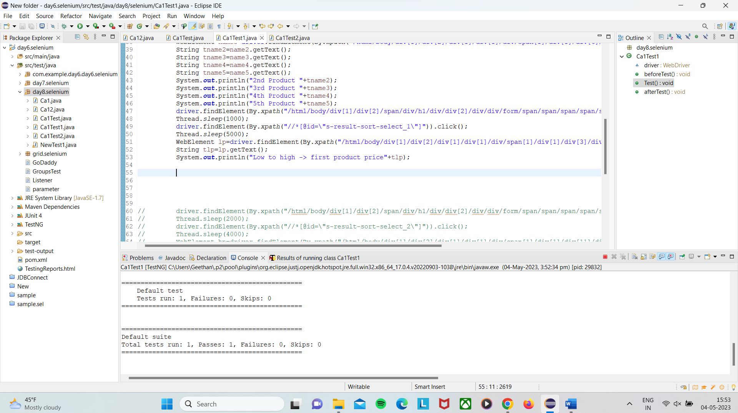

3. **package** day8.selenium;

**import** org.openqa.selenium.By;

**import** org.openqa.selenium.Keys;

**import** org.openqa.selenium.WebDriver;

**import** org.openqa.selenium.WebElement;

**import** org.openqa.selenium.firefox.FirefoxDriver;

**import** org.testng.annotations.AfterTest;

**import** org.testng.annotations.BeforeTest;

**import** org.testng.annotations.Test;

**public** **class** Ca1Test2 {

WebDriver driver;

@BeforeTest

**public** **void** beforeTest() {

driver=**new** FirefoxDriver();

}

@Test

**public** **void** Test() **throws** InterruptedException {

String url="https://www.amazon.in/";

driver.get(url);

driver.manage().window().maximize();

Thread.*sleep*(5000);

System.***out***.println("opened");

driver.findElement(By.*xpath*("//*[@id=\"nav-link-accountList\"]")).click();

Thread.*sleep*(5000);

driver.findElement(By.*xpath*("//*[@id=\"ap_email\"]")).sendKeys("7418736104",Keys.***ENTER***);

Thread.*sleep*(7000);

driver.findElement(By.*xpath*("//*[@id=\"ap_password\"]")).sendKeys("Charishmatic04",Keys.***ENTER***);

Thread.*sleep*(4000);

driver.findElement(By.*xpath*("//*[@id=\"nav-link-accountList\"]")).click();

Thread.*sleep*(5000);

driver.findElement(By.*xpath*("/html/body/div[1]/div[2]/div/div[2]/div[1]/a/div/div/div/div[2]/h2")).click();

Thread.*sleep*(4000);

driver.findElement(By.*xpath*("//*[@id=\"a-autoid-2-announce\"]")).click();

Thread.*sleep*(4000);

driver.findElement(By.*xpath*("/html/body/div[1]/div[2]/div/div[5]/div[2]/div/div/div/a")).click();

Thread.*sleep*(5000);

driver.findElement(By.*xpath*("//*[@id=\"Cancel-items_1\"]")).click();

Thread.*sleep*(5000);

driver.findElement(By.*xpath*("/html/body/div[1]/form/table[2]/tbody/tr/td/table/tbody/tr/td/table/tbody/tr/td/table/tbody/tr/td/div/table/tbody/tr/td/p[1]/span/span/span/input")).click();

Thread.*sleep*(10000);

WebElement txt=driver.findElement(By.*xpath*("/html/body/div[1]/div[2]/div[2]/div/h4"));

String str=txt.getText();

System.***out***.println("Deleted ALert Message "+str);

}

@AfterTest

**public** **void** afterTest() {

driver.quit();

}

}



